自控作業2 E14056499 林俊佑

**Code:**

clear all,close all,clc

k= 3

Cs=zpk([],[1],k)

Cg=zpk([],[-2],1)

CsCg=series(Cs,Cg)

sys=feedback(CsCg,1,-1)

pole=pole(sys)

t = 0:0.01:4

input = exp(t)

figure(2)

lsim(sys,input,t)

**Output:**

k = 3

Cs =

3

-----

(s-1)

Continuous-time zero/pole/gain model.

Cg =

1

-----

(s+2)

Continuous-time zero/pole/gain model.

CsCg =

3

-----------

(s+2) (s-1)

Continuous-time zero/pole/gain model.

sys =

3

-------------

(s^2 + s + 1)

Continuous-time zero/pole/gain model.

pole = 2×1 complex

-0.5000 + 0.8660i

-0.5000 - 0.8660i

**Ans:**

(a)

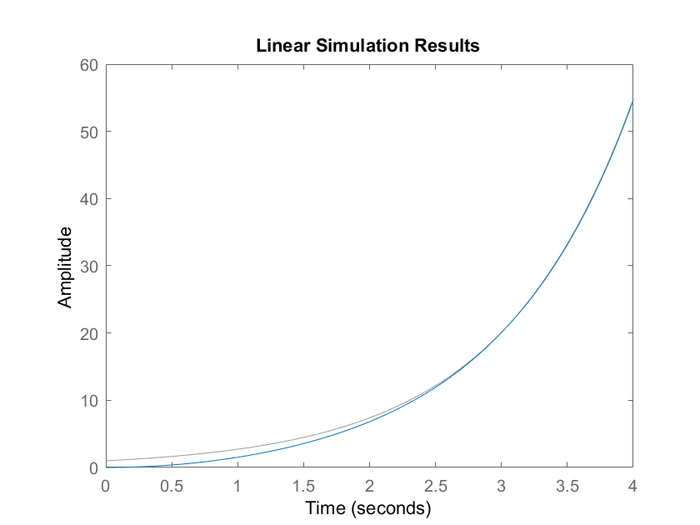

(b) ts = 2.5s